
LYTCHETT MATRAVERS
“NOT JUST” WI
6th November 2019
7.30pm at the Village Hall.
POTTERY EVENING
We welcome Alan White, Master Potter from Poole Pottery who is going to demonstrate the craft of pottery. Someone may even get a chance to have a go!!

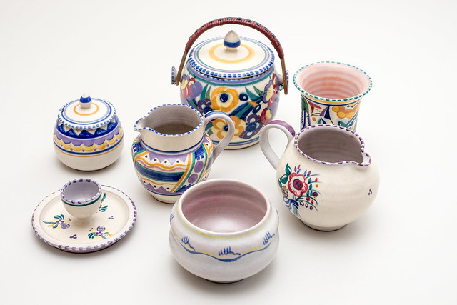

Non-members and guests are very welcome for a suggested donation of £5. Why not join?? Other WI members a suggested donation of £3.
Look us up on the Website www.notjustwi.com or find us on facebook by searching notjustwi. Any queries call Debbie on 01202 621671.

