
WELCOME TO LYTCHETT MATRAVERS “NOT JUST” WI

We are really pleased that you have decided to join us and become a member, not only within our group but alongside other women across the nation.
When are the meetings held and what happens?
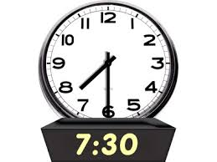
We meet on the first Wednesday of the month except for August.
We start promptly at 7.30pm once registration has been completed, and you have collected any magazines, newsletters and purchased raffle tickets. The meeting commences with the welcome of all members and visitors. The President will then introduce the speaker for the evening which usually lasts for an hour. Refreshments follows the speaker which is usually tea, coffee and biscuits. The formal meeting follows the speaker and this is minuted. This part of the meeting covers matters arising, correspondence from the Dorset Federation of Women’s Institutes and other groups and Organisations. There are also discussions about trips and other social activities and ends with any other business. The raffle concludes the evening.
What the WI Committee look like and what does it do?

The Not Just WI Committee has 10 members including a President and deputies, Treasurer and Secretary. The Committee meet every month, a week before the Not Just meeting. This allows for future planning. Not Just WI members are welcome to join the Committee when vacancies arise, usually at the Annual meeting, although members can volunteer at anytime. We do acknowledge times of sadness, ill health and significant times in lives with cards flowers and good wishes for our members.

Is there any formal business?
Every April the “Not Just” WI have their annual meeting. The secretary will read out the annual report and a financial summary is provided by the Treasurer who has had the accounts audited in December. This is also the time when new committee members are voted on. We do encourage members to attend this meeting to ensure that they have a vote.
What other things happen within the “Not Just” WI?
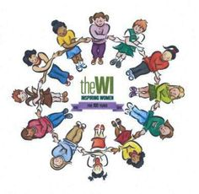
We have 2 social evenings a year, Christmas and Summer. At the Christmas social we all bring food to share and drinks are provided by the WI. We usually look at getting some entertainment!! At the Summer social as well as bringing in food to share we ask members to put forward ideas for the following years talks, demonstrations, trips etc.
We organise fund raising annually supporting the ACWW (Association for the Women of the World). We sometimes have a stall at the Village Fair. The “Not Just” WI organise a Christmas Fair at the Village hall where we organise Crafts and people to have stalls to raise funds for our activities.
Members are invited annually to volunteer at Camp Bestival to work in the WI Tea Tent. There is always a fantastic atmosphere and everyone enjoys the experience.
We also organise trips in Summer and Winter eg Christmas Markets, Walk, Theatre and Boat trips.
How Can I volunteer to help at the meetings?
Each month members are asked to enlist themselves on the rota to help in the kitchen with making and serving the refreshments and also washing up. A member of the Committee does lead this and supplies the tea, coffee, milk etc
Do we have a County Base?
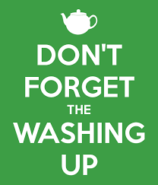
The Dorset Federation of Women’s Institute (DFWI) is based in the County Office in Dorchester. Most of our correspondence comes from the DFWI. Every year the DFWI have an Annual meeting, this is usually held at The Lighthouse in Poole. There are 2 speakers at this meeting one before and one after lunch, previous speakers have been Ann Widdecombe and Adam Henson. Tickets for this event can be bought through the Not Just WI and during intervals and lunchtimes there are stalls selling produce, craft and WI merchandise.
How are we involved with other WI’s
Not Just WI is part of a group of WI’s that meet 3-4 times a year, this group is the Woodbury Hill group. During the year we have events where we all are invited which is good to meet other people from other WI’s. There is a member of the Committee who attends the meetings to represent out WI.
What else is included in our subscription?

There is no need to pay for refreshments at meetings. When outings and trips are organised we look to subsidise these although we are unable to pay transport costs. Members do receive magazines including the “WI Life” and the WI News. Funds are accumulated through fundraising events. Monies are used to pay for speakers and refreshments at the social evenings.

What happens now?

We hope you will enjoy your time and meet new friends!! We do have facebook - notjustwi and website www.notjustwi.com .

